Spring 1
Week 3
To support your child with their word reading, each week we will be sending home a list of the focus sounds/words that your child has been learning in school in addition to their decodable reading books. Please spend time reading these sounds/words at home.

le (as in, apple)  apple  gentle  beetle  sparkle  puddle  bubble | Tricky words  These words cannot be read phonetically as they break some of the phonics rules! Practise reading these words from sight.  ask  Mr  Mrs  Ms  school  call  different
al (as in, metal)
total
equal
final
metal
petal
pedal
c (as in, ice)  face  space  ice  suc/cess  mice  nice | Write  Slowly read this sentence to your child and see if they can write it independently using their phonics knowledge.  The yellow sun in the sky makes us feel happy.
ve (as in, give)  give  live  solve  leave | 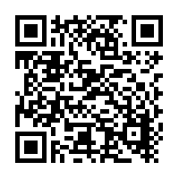  Scan this code using a phone or IPad to watch helpful videos and find downloadable resources linked to the sounds.

