Spring 2
Week 3
To support your child with their word reading, each week we will be sending home a list of the focus sounds/words that your child has been learning in school in addition to their decodable reading books. Please spend time reading these sounds/words at home.

a (as in, water)  ball  call  water  tall  call  small  always | Tricky words  These words cannot be read phonetically as they break some of the phonics rules! Practise reading these words from sight.  who  whole  because  eye  people  thought  through
a (as in, want)
want
what
squash
swap
wasp
watch
ear (as in, bear)  pear  bear  wear  tear  swear | Write  Slowly read this sentence to your child and see if they can write it independently using their phonics knowledge.  I can bounce a ball on the floor and catch it.
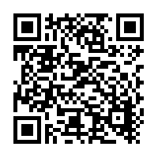
Scan this code using a phone or IPad to watch helpful videos and find downloadable resources linked to the sounds.

